Finishing Sander
QUALITY

YEAR
1

Finishing Sander

FS2001

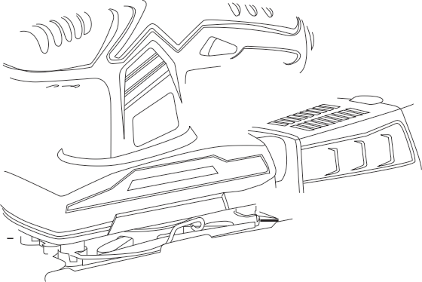
INGCO TOOLS CO.,LIMITED www.ingcotools.com MADE IN CHINA
0414.V01
produced & marketed
by

EN Finishing Sander
ES Lijadora de acabado

SAFETY INSTRUCTIONS

WARNING! Read all safety warnings and all instructions. Failure to follow the warnings and instructions may result in electric shock, ﬁre and/or serious injury.
Save all warnings and instructions for future reference.
The term “power tool” in the warnings refers to your mains-operated (corded) power tool or
battery-operated (cordless) power tool.

SAVE THESE INSTRUCTIONS
1. Work area safety
a) Keep work area clean and well lit. Cluttered and dark areas invite accidents.
b) Do not operate power tools in explosive atmospheres, such as in the presence of
ﬂammable liquids, gases or dust. Power tools create sparks which may ignite the dust
or fumes.
c) Keep children and bystanders away while operating a power tool. Distractions can cause you to lose control.
2. Electrical safety.
a) Power tool plugs must match the outlet. Never modify the plug in any way. Do not
use any adapter plugs with earthed (grounded) power tools. Unmodiﬁed plugs and
matching outlets will reduce risk of electric shock.
b) Avoid body contact with earthed or grounded surfaces such as pipes, radiators, ranges and refrigerators. There is an increased risk of electric shock if your body is earthed or grounded.
c) Do not expose power tools to rain or wet conditions. Water entering a power tool will increase the risk of electric shock.
d) Do not abuse the cord. Never use the cord for carrying, pulling or unplugging the power tool. Keep cord away from heat, oil, sharp edges or moving parts. Damaged or entangled cords increase the risk of electric shock.
e) When operating a power tool outdoors, use an extension cord suitable for outdoor use. Use of a cord suitable for outdoor use reduces the risk of electric shock.
f ) If operating a power tool in a damp location is unavoidable, use a residual current device (RCD) protected supply. Use of an RCD reduces the risk of electric shock.
3. Personal safety.
a) Stay alert, watch what you are doing and use common sense when operating a
power tool. Do not use a power tool while you are tired or under the inﬂuence of
drugs, alcohol or medication. A moment of inattention while operating power tools may
result in serious personal injury.
b) Use personal protective equipment. Always wear eye protection. Protective equipment such as dust mask, non-skid safety shoes, hard hat, or hearing protection used for appropriate conditions will reduce personal injuries.
c) Prevent unintentional starting. Ensure the switch is in the oﬀ-position before connecting to power source and/or battery pack, picking up or carrying the tool. Carrying power tools with your ﬁnger on the switch or plugging in power tools that have the switch on invites accidents.
d) Remove any adjusting key or wrench before turning the power tool on. A wrench or a key left attached to a rotating part of the power tool may result in personal injury.
e) Do not overreach. Keep proper footing and balance at all times. This enables better

control of the power tool in unexpected situations.
f ) Dress properly. Do not wear loose clothing or jewelry. Keep your hair, clothing and gloves away from moving parts. Loose clothes, jewelry or long hair can be caught in moving parts.
g) If devices are provided for the connection of dust extraction and collection facilities, ensure these are connected and properly used. Use of these devices can reduce dust-related hazards.
4. Power tool use and care.
a) Do not force the power tool. Use the correct power tool for your application. The
correct power tool will do the job better and safer at the rate for which it was designed.
b) Do not use the power tool if the switch does not turn it on and oﬀ. Any power tool that cannot be controlled with the switch is dangerous and must be repaired.
c) Disconnect the plug from the power source and/or the battery pack from the power tool before making any adjustments, changing accessories, or storing power tools. Such preventive safety measures reduce the risk of starting the power tool accidentally.
d) Store idle power tools out of the reach of children and do not allow persons unfamiliar with the power tool or these instructions to operate the power tool. Power tools are dangerous in the hands of untrained users.
e) Maintain power tools. Check for misalignment or binding of moving parts, breakage of parts and any other condition that may aﬀect the power tools operation. If damaged, have the power tool repaired before use. Many accidents are caused by poorly maintained power tools.
f ) Keep cutting tools sharp and clean. Properly maintained cutting tools with sharp cutting edges are less likely to bind and are easier to control.
g) Use the power tool, accessories and tool bits etc., in accordance with these instructions and in the manner intended for the particular type of power tool, taking into account the working conditions and the work to be performed. Use of the power tool for operations diﬀerent from intended could result in a hazardous situation.
5. Service
a) Have your power tool serviced by a qualiﬁed repair person using only identical
replacement parts. This will ensure that the safety of the power tool is maintained.

ADDITIONAL SAFETY INSTRUCTIONS FOR YOUR SANDER

1. Remove the plug from the socket before carrying out any adjustment, servicing or maintenance.
2. Fully unwind cable drum extensions to avoid potential overheating.
3. When an extension cable is required you must ensure it has the correct ampere rating for your power tool and is in a safe electrical condition.
4. Ensure your mains supply voltage is same as indicated on the rating plate.
5. Your tool is double insulated for additional protection against a possible electrical insulation failure within the tool.
6. Always check walls, ﬂoors and ceilings to avoid hidden power cables and pipes.
7. After long working periods external metal parts and accessories could be hot.

8. Wear eye protection when operating this tool.
9. If possible, ensure the workpiece is ﬁrmly clamped to prevent movement.
10. Your ﬁnishing sander is a hand held tool, do not clamp your ﬁnishing sander.
11. Before sanding, check the area is free of nails, screws, etc.
12. Never stop the ﬁnishing sander by applying a force to the baseplate.
13. Only use paper in good condition. Do not use torn or worn paper.
14. Do not sand material containing asbestos due to a health risk.
15. Do not sand lead based paint due to the risk of lead poisoning.
16. Do not eat or drink in the working area of the sander.
17. Do not allow people to enter the working area without wearing a dust mask.
18. Where possible, seal oﬀ the working area to contain the dust for later removal.
19. Always wear a dust mask.
20. Your tool is designed for dry sanding only, not wet sanding.
21. Your tool is designed for general purpose light polishing of wood and metals.
22. Do not sand magnesium material due to the risk of ﬁre.

WARNING: Some dust particles created by power sanding, sawing, grinding, drilling and other construction jobs contain chemicals known to cause cancer, birth defects or other reproductive harm. Some examples of these chemicals are:
Lead from lead-based paints. Crystalline silica from bricks and cement and other masonry products. Arsenic and chromium from chemically treated lumber. Your risk form these exposures varies, depending upon how often you do this type of work. To reduce your exposure to these chemicals:
Work in a well ventilated area. Work with approved safety equipment, such as those dust masks that specially designed to ﬁlter out microscopic particles and use the dust bag at all times.

DOUBLE INSULATION

The tool is double insulated. This means that all the external metal parts are electrically insulated from the mains power supply. This is done by placing insulation barriers between the electrical and mechanical components making it unnecessary for the tool to be earthed.

IMPORTANT NOTE

Be sure the supply is the same as the voltage given on the rating plate. The tool is ﬁtted with a two-core cable and plug. Remove the mains plug from socket before carrying out any adjustment or servicing.

SYMBOLS

Read the manual

Double insulation

Warning

Wear dust mask, eye & ear protection

WEEE marking

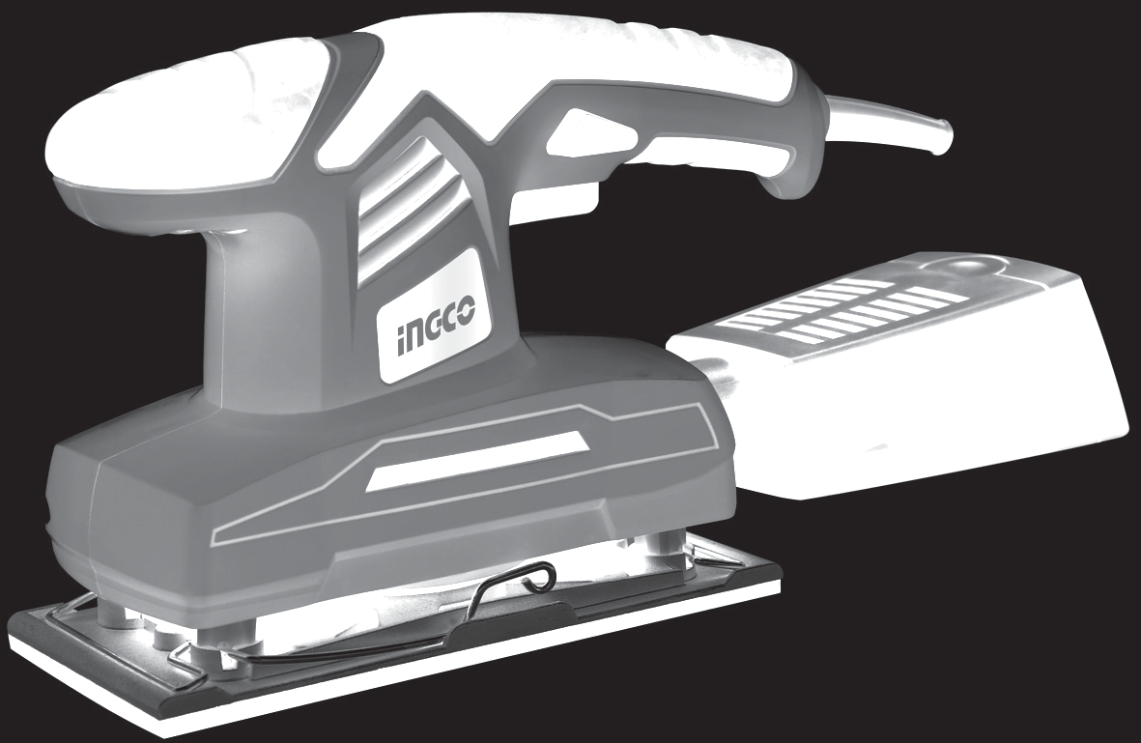4

3

1 2

1. Sanding sheet clamping system
2. Aluminium durable sanding plate
3. Auto dust extraction function
4. Soft grip for more comfortable hold

Not all the accessories illustrated or described are included in standard delivery.

TECHNICAL DATA

Model No.

Rated power input

Rated voltage No-load speed Bottom base

ACCESSORIES
FS2001

200W

220-240V~50-60Hz

11000rpm

187x90mm

• 1pcs dust box • 1pcs sand paper • 1set carbon brush

OPERATING INSTRUCTIONS

NOTE: Before using the tool, read the instruction book carefully.

1. FITTING THE SANDING PAPER (See Fig. A, B, C)

Lift the sanding paper retaining clips to the open position and insert one end of the sanding paper under the retaining clip.

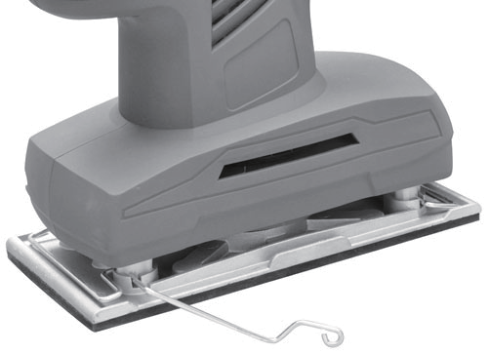
Fig. A

Push the clip back into the retaining position. Lightly stretch the paper over the base plate ensuring that it is not folded
or wrinkled then position under the other retaining clip back into the retaining position. Check that the paper is flat to
the base plate, if not, release either clip and reposition the paper before resetting the clip. Switch on momentarily to check that the sander is functioning correctly. If there is undue vibration, repeat the paper positioning procedure.
Fig. B

2. DUST COLLECTION BOX (see Fig.C Your sander is equipped with a dust collection box. To attach, insert the Dust collection box into the back of the sander in correct position. Then turn the bag to
90° clockwise. Pull the bag and make sure the bag is tightened securely on the dust
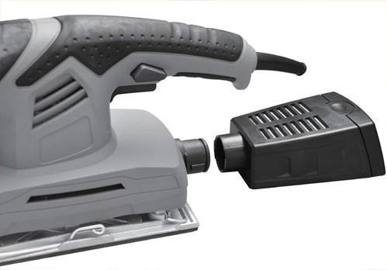
Fig. C

3. OPERATING THE ON/OFF SWITCH (see
Fig.C )
ON /OFF SWITCH
Depress to start and release to stop your tool.
SWITCH LOCK-ON BUTTON
Depress on/o switch (1) then lock-on button (2), release on/o switch first and lock-on button second. Your switch is now locked on for continuous use. To switch o your sander just depress and release the on/o switch.

4. USING THE SANDER (See Fig.D ) The workpiece to be sanded must be secured. If it is small or it may move during sanding, it must be held in a vice or suitably clamped.
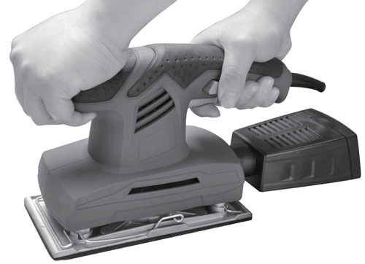Be sure to hold the sander firmly whilst it is on and apply it gently to the work, it may “kick” on first contact. Hold the sander so that it is flat on the work and move slowly, preferably with a smooth, circular motion. Regularly check the condition of the sanding paper and replace when worn for best results.

Fig. D
MAINTENANCE

Remove the plug from the socket before carrying out any adjustment, servicing or maintenance.
Your power tool requires no additional
lubrication or maintenance.
There are no user serviceable parts in your power tool. Never use water or chemical cleaners to clean your power tool. Wipe clean with a dry cloth. Always store your power tool in a dry place. Keep the motor ventilation slots clean. Keep all working controls free of dust. Occasionally you may see sparks through the ventilation slots. This is normal and will not damage your power tool.
If the supply cord is damaged, it must be replaced by the manufacturer, its service agent or similarly qualified persons in order to avoid a hazard.

TROUBLESHOOTING

1. If your sander will not operate, check the power at the mains plug.
2. If the sander does not abrade surface, checking the sanding paper. If the sanding paper have been worn, replace the new paper and try again. The paper must be
kept in a dry place, if it is allowed to become damp, the abrasive particles will lose their adhesion to the backing paper and will not abrade.
3. If the sander dose not move smoothly, The sanding paper may be loose, damaged or wrinkled. Replace and try again.
4. If a fault can not be rectified return the sander to an authorized dealer for repair.

FS2001 Spare part list
No | Part Description | Qty
1 | Left House | 1
2 | Press Board | 1
3 | Screw | 2
4 | Cord Protector | 1
5 | Power Cord | 1
6 | Dust Cove | 1
7 | Dust Box | 1
8 | Adaptor | 1
9 | Switch | 1
10 | Bearing | 1
11 | Carbon Brush | 2
12 | Rotor | 1
13 | Stator | 1
14 | Screw | 10
15 | Right House | 1
16 | Cooling Fan | 1
17 | Bearing | 1
18 | Aluminium Fan | 1
19 | Bracket | 2
20 | Bearing | 1
21 | Washer | 1
22 | Spring Mattress | 1
23 | Screw | 1
24 | Steel Clamp | 2
25 | Aluminium Base | 1
26 | Sanding Plate | 1
27 | Screw | 4

FS2001 Exploding view

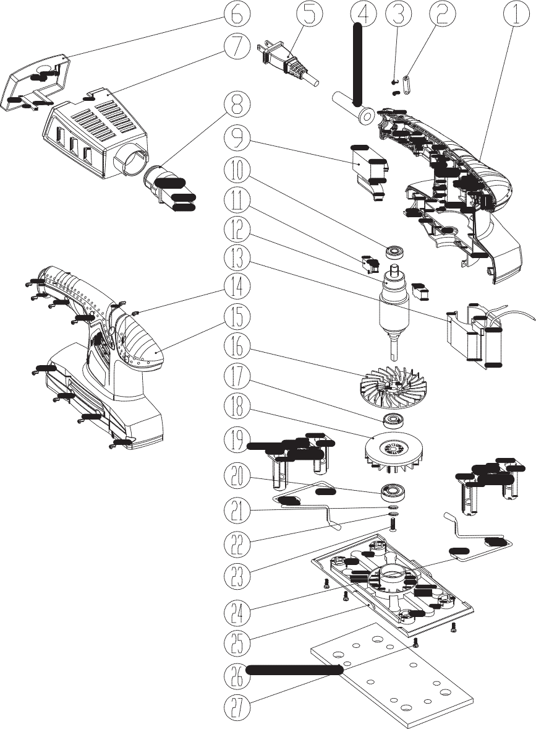

FS2001

3
EN Finishing Sander
ES Lijadora de acabado

4 5

1 2

